|  |  |  |
| --- | --- | --- |
| Pradeep | Pradeep | Pradeep |
| Pradeep | Pradeep | Pradeep |
| Pradeep | Pradeep | Pradeep |
| Pradeep | Pradeep | Pradeep |
|  |  |  |

|  |  |  |  |  |  |  |  |
| --- | --- | --- | --- | --- | --- | --- | --- |
| 1 4 55 5 2  2 4 5 5 2  4 4 5 5 2  3 4 5 5 2  5 4 5 5 2  **December** | | | | | | | |
| M | T | W | T |  | F | S | S |
|  |  |  |  |  |  |  | 1 |
| 2 | 3 | 4 | 5 |  | 6 | 7 | 8 |
| 9 | 10 | 11 | 12 |  | 13 | 14 | 15 |
| 16 | 17 | 18 | 19 |  | 20 | 21 | 22 |
| 23 | 24 | 25 | 26 |  | 27 | 28 | 29 |
| 30 | 31 |  |  |  |  |  |  |

Sub script:Hlop22., H2SO4 Super script:a2+2ab +b2

**IMAGES**

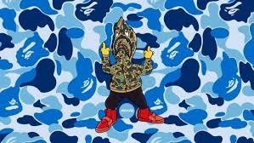

1

* Pradeep
* Pradeep

2

* Pradeep
* Pradeep

3

* Pradeep
* Pradeep

**List**

**Process**

Pradeep

Pradeep

Pradeep

Pradeep

Pradeep

**CYCLE**

Pradeep

Pradeep

Pradeep

Pradeep

Pradeep